Institutional Effectiveness Steering Committee 15th May 2024 meeting Agenda
  - Members: Gail Hamilton, Manuel Caballer, Zarifa Mirzayeva, and Claudio Piani
- Welcome members present (apologies).
- Approval of agenda
- Debrief Outcomes Assessment day. How did it go (Report attached)?
  - Did we accomplish our goals? Will more people use LMS for their assessment/ do assessment properly/ do a better advising job?
  - Do we have any pictures?
    - Check …
  - Next year we will dedicate it entirely to the reaccreditation.
    - Give away a ham…
- We have to start thinking of the new MSCHE Standards and suggested evidence. This committee will take on new, more active, responsibilities.
  - Should we expand the committee?
  - Should Jessica replace Zarifa if she will be in charge of the Evidence Inventory (question for Zarifa)?
  - I will ask the provost for a new Faculty member.
- Closing remarks for the year.

-This committee was the old Steering committee for Reaccredtation
-Chair and sun chair for each standard
-Do we want someone in finance, Student affairs, Registrar. Provost will give guidance.
-EI responsible person?
-New CFO? Good time to get someone from Finance
-Budget committee?
-Not have a proper full steering committee.
-Admissions, finance, Registrar, ACE (Isabella A.), IREA, Mayra (too busy now…), Kim?, new Faculty?
-Yes to reinforce the IESC with reps from groups outside AA.
-

Outcomes Assessment Day May 2nd, 2024: Final Report (No Annexes)
Dear Colleagues,
On May 2nd 2024, we held our annual Outcomes Assessment Day. The objective of the University Outcomes Assessment Day is threefold: first, to allow members of different units to gain a better understanding of each other’s work, plans, challenges, and achievements; second, to share assessment best practices and to support each other in the continuous improvement of assessment processes; third, to propose, develop, and lead focused workshops on key themes than interest a cross-cutting section of the University community. After a few words of welcome from our Provost, who reminded us of our necessary commitment to continuous, authentic, and pervasive assessment, I spoke very briefly of what I believe are the recent changes in our assessment culture as well as the emerging challenges.
Foremost among these challenges is the upcoming MSCHE reaccreditation planned for 2027/28. The reason we are planning for this event with so much lead time is the recent revision of the standards of accreditation in July 2023. Along with the new standards, MSCHE has also established a catalog of suggested documents for the Evidence Inventory aligned with the criteria and sub-criteria of each standard. In general the documentation in the evidence inventory must span the 4 years prior to the self-study. We have already begun the process of identifying gaps in the documentation.
After discussing MSCHE and the new accreditation process, I gave a brief presentation of the day’s activities starting with the three workshops to follow:
- Making Blackboard, or any other LMS, do your assessment for you. (Led by Kevin Dixey and Jennifer Dixey, ARC).
- Improving opportunities for academic and career exploration with ACE. (Led by Isabella Archer and Linda Martz, ACE)
- Intro to Assessing Student Learning. (Led by Claudio Piani, Dean IRAE)
In keeping with the maxim “if there is no report, there was no meeting”, which we all enthusiastically adhere to, I am circulating the notes from the workshop leaders. If there is anything you want to add to these notes, do email me. I will add your comments to this report which will inform the Annual Institutional Effectiveness report drafted by myself and due in fall 2024.
Sincerely
Claudio Piani

Schedule
9:00 | Coffee and Viennoiseries (C101)
9:30 | Welcome from the Provost (C104)
9:40 | Presentation from the Dean of Institutional Effectiveness: Assessment after (after?) Covid.
10:00 | Workshops
10:30 | Workshops
11:00 | Workshops
11:30 | Coffee break (C101)
12:00 | Panel of Workshop Rapporteurs
12:30 | Closing Remarks
13:00 | Lunch and Mingling

Workshops

Making Blackboard, or any other LMS, do your assessment for you.
  - Led by Kevin Dixey and Jennifer Dixey (ARC).
Can your Learning Management System (LMS), currently Blackboard, be harnessed to automate the assessment process at AUP? The answer is yes and, in this workshop, we will show you the various ways this can be done. Once the Learning Outcomes are uploaded to your BB page by the system administrator, we will show you how to:
- Find your LOs on your BB course site.
- Link your LOs to a specific assignment, test, etc.
- How to see the LOs in your gradebook
- If you use a grading rubric, how to link the LO to a rubric
- How to produce an assessment report.
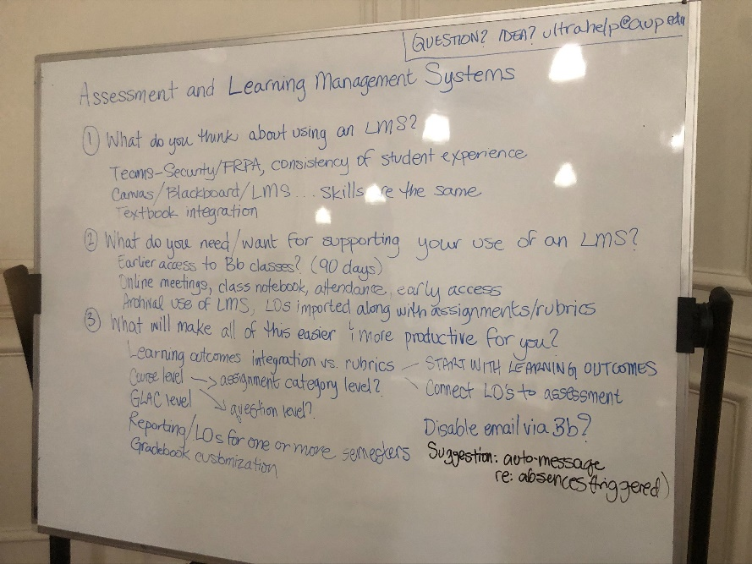
Responses from participants in Workshop #1
After a brief presentation covering the above five points, we began a series of real time surveys to gain insight on the level of acceptance of, and familiarity with, Blackboard Ultra as an assessment tool. Wea asked the following questions:
- What do you think about using an LMS?
  - When using TEAMS, some faculty have misgivings about security issues and FERPA/DPR
  - What are the benefits of different LMS? Canvas, Blackboard (Ultra), Teams, other…
  - How easy is it to integrate a textbook
- What do you need/want for supporting your use of an LMS?
  - Earlier access to my Bb classes. For example 90 days.
  - Online meetings, class notebook, attendance..
  - Archival use of LMS, LOs imported along with assignments and rubrics with the goal of creating an automated system of assessment reporting.
- What will make all of this easier and help you be more productive?
  - Integration of Learning Outcomes with evaluation rubrics.
  - Use this to connect LOs to assessment.
  - Assing both course LOs, and program LOs to evaluations. Programs can be Majors, Master’s and GLACC components.
  - Automate reporting of assessment for courses/majors/Master’s/GLACC
  - Customize the gradebook.

Improving opportunities for academic and career exploration with ACE.
  - Led by Isabella Archer and Linda Martz (ACE)
ACE is planning to pilot a new organizational structure in the fall which is designed to reinforce links between advising and the departments, as well as ACE and administrative units. We will present the proposed structure and how it evolved, and then solicit feedback on how we can improve academic advising, the GPS program, and internal internship opportunities at AUP.
The ACE workshop commenced with a brief presentation about the ACE program, followed by an interactive activity called "Two Truths and a Lie" to gauge participants' understanding of ACE. This report synthesizes the discussions, issues raised, and proposals made during the workshop.

Faculty Insights
Faculty expressed thoughts on transfer credits, suggesting that while degree programs and departmental structures are essential, there are numerous additional activities and initiatives that should be pursued to enhance the educational experience.
Key Issues and Discussions

Advising Responsibilities
Current Situation: ACE advisors are currently handling senior students' advising, which ideally should be managed by the respective departments.
Challenge: Determining who should advise whom and addressing the uneven distribution of advising loads among faculty.

Degree Worksheets and FERPA Compliance
Issue: Managing and updating degree worksheets while ensuring compliance with FERPA, avoiding duplicated efforts, and providing necessary access to relevant personnel.
Study Abroad and Placement Tests

Options for study abroad programs were presented.
Placement tests, managed by ARC, need to be timely. A suggestion was made to require all students to take math placement tests early, or obtain waivers, to streamline the process.
Advising Loads and Difficult Cases. Faculty noted that not all advisees are the same, with 80% of advising time often spent on 20% of students. There is a need to develop processes for handling more challenging cases effectively.

Student Perceptions and System Design
It was emphasized that AUP systems are designed to benefit all students and not to cater to a few who may not plan adequately.

Internships and Employer Relations
Discussions on the management of internships and the clarification of employer relations highlighted the existence of two separate databases: one for classified jobs and another for job/internship opportunities.

Graduate Programs (GPS)
GPS programs are too short to allow proper completion, prompting suggestions for future development. Historical context and ongoing conversations with GLACC and CC were mentioned.

Program Assessment and Restructuring
The need to assess and potentially restructure programs to enhance the experiential learning aspect and build professional skills was discussed.

Student Awareness and Degree Programs
Faculty observed that students are often unaware of how various systems work and their benefits. There is a need to view degree programs as comprehensive experiences beyond just collections of courses.

Empowering Students
Empowering students to take ownership of their degree programs and progress through the GPS system was identified as a critical issue.

The Plan: ACE 2.0 – The “Petal Project”
The plan involves assigning academic and career advisors to specific departments to integrate and streamline advising and career support.
Efforts to enhance training on FERPA compliance and the need-to-know basis for accessing student records were highlighted.

Additional Talking Points
- The unpredictability of advising needs.
- Clarifying policy and process information to make faculty advisors' roles clearer.
- Addressing overenrolled courses and optimizing course scheduling.
- Implementing scheduling guidelines to aid visibility and predict scheduling needs.
- Enhancing partnerships and internship opportunities, especially for graduate management students, and leveraging alumni networks for sustainable opportunities.
- Revising First-Year Seminar (FYS) policies.
- Promoting project-based learning as a cornerstone of economics and management education. The suggestion included creating an “Institutional Experiential Learning” course to structure internal projects as learning experiences for students.

Conclusion
The ACE workshop provided a valuable platform for discussing current challenges and proposing innovative solutions to improve academic and career advising at AUP. The insights and plans presented aim to enhance the overall student experience, ensuring it is both comprehensive and empowering.

Acknowledgement
Thank you for the opportunity to present these ideas and engage in meaningful discussions with our colleagues.

First Steps in Assessment (for New Faculty)
  - Led by Claudio Piani
New to assessment? Don’t know what to do? Assessment should not be overly burdensome, and it should not be something that you need to do perfectly on your first attempt. The Middle States Commission on Higher Education, our main accreditation body, is very much in support of “continuous improvement”. So as long as you incrementally strengthen your assessment process, you are in compliance with our assessment requirements and you are contributing to the University’s accreditation effort.
In this workshop I will assist you in setting up the most basic form of assessment and assessment reporting for a course of your choice. By the end of the session, you will have:
- Identified an assessment method for a learning outcome of your choosing and for a course of your choosing (test, presentation, performance art, or another student artifact).
- Drafted an evaluation rubric or blueprint for that LO and that methodology.
- Drafted an assessment report.
*Senior faculty are welcome but questions from your more junior colleagues will take precedence.

Notes from meeting from Claudio Piani:

- A total of 10 faculty participated. All participants had one or more years experience teaching at AUP either as CDIs or CDDs.
- The CLEN, E&M, H&P, and CSMES departments were represented.
- The workshop began with a 20 min. standard presentation on how assessment is done and how to draft helpful assessment rubrics for LOs.
- Then faculty were asked to pair-up, invent a course and devise helpful and measurable LOs. Among the very interesting courses suggested were.
  - Paris to Cairo, the 19th Century
  - Financial Literacy
- Each faculty pair was asked to draft an evaluation rubric for their LOs using the methodology and tips resented earlier.
- For each of their LOs, faculty were asked to draft a mock assessment report, including “evidence”, “conclusions’, and “results”, as well as an alignment matrix either with a major of choice or with the institutional Core Capabilities.
The workshop ended with a Q&A. Below are some of the questions asked and answered.
- Can I use the assessment rubric for grading as well? Yes. One would hope that there is a non-insignificant relation between the grades your students achieve and the learning. There is a straightforward way that the assessment effort can produce grades concurrently.
- Do all courses have to be assessed? Yes, all courses have to be assessed, in fact all activities that contribute to the advancement of the University’s mission, have to be assessed but not all the time.
- Can I decide what the LOs of my course are? When proposing a new course to the Curriculum Committee, you must include the Learning Outcomes (LOs), which the Committee will review. The Committee ensures that the LOs are measurable and consistent with the program's goals. Once the course is listed in the catalog, the LOs cannot be altered without re-approval from the Committee. If there is a mistake in the LOs in the catalog, you can request the Registrar to correct it.Do we assess every semester? Currently I am asking faculty to turn in assessment results in the Fall. I will shortly change that to Spring just to keep things fresh.
- What happens to my assessment results? Does anyone read or care about what I write? Your course assessment results will contribute to the assessment of the programs (majors, Master’s, GLACC) the are part of. Jessica and I actually spend time cutting and pasting what you give us and collate the results for the program directors and department chairs to look at.
- Some Assessment Tables are included in more than one report. For example, the results for CCE are included in the CLEN Department and the GLACC Brief.

Email from Gail 21 Feb. 2024
Hi Claudio,

Here are summary comments based on 9 interviews with Chairs and Program Directors:

Do you find the current Curricular Review process and its guidelines to be a supportive tool in designing and improving your department or program’s curricula? Why or why not?

Generally, yes. A few comments and suggestions:
- The guidelines are “loose” enough” to be useful
- Coaching by Academic Affairs was helpful
- Advice from other chairs may be useful
- Choose external reviewers carefully – this is an important piece of the process
- How to best insure full participation from the Department?
  - “The requirement to involve all department was the more effective part.”
  - “Everyone contributed to design, took part, etc. This was useful but not necessarily because of the process structure.”

Problems highlighted by the Chairs and Program Directors were linked to follow-on activities such as curricular approval processes or lack of resources to implement action items highlighted in the Review.

So overall, no modifications to the Curriculum Review Process document are needed at this time.

Cheers, Gail

