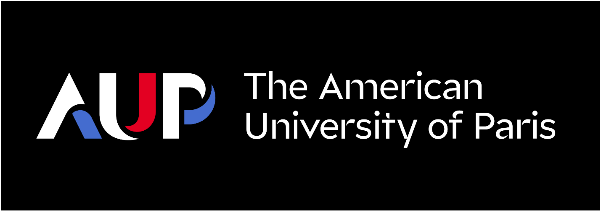
Gender Equality Plan, January 2024
Endorsed by the Provost Dr. Hannah Westley,
and Dean on Institutional Effectiveness Prof. Claudio Piani

Contents
About the Gender Equality Plan 1
AUP Specific Context 1
French Context 1
USA Context 1
Mandatory Criteria 2
A Publicly Available Gender Equality Plan 2
Resource Commitment and Expertise in Gender Equality 3
Data Collection and Monitoring 3
Training on Gender, Equality and Unconscious Bias for all Staff and Decision Makers 5
Recommended Areas of Focus 5
Work-Life Balance and Organizational Culture 5
Gender Balance in Leadership and Decision Making 5
Gender Equality in Recruitment and Career Progression 6
Integration of the Gender Dimension into Research and/or Teaching Content 6
Measures Against Gender-Based Violence Including Sexual Harassment 6

About the Gender Equality Plan
The Gender Equality Plan (GEP) at the American university of Paris (AUP) describes a virtuous cycle of data gathering, assessment and analysis, developing actions and initiatives in response to emerging needs, and the implementation of such actions and initiatives. The effects and outcomes of actions and initiatives are then monitored in the initial data gathering phase of the following cycle. A common and not unimportant class of actions are improvements and additions to the GEP itself.
The drafting and publication of the GEP is in response to an EU requirement for participation in all HORIZON 2022 funded projects beginning in 2022. All foundational elements of the GEP, dedicated resources, data gathering, staff and faculty training, as well as its foci, leadership, recruitment and career progression, sexual harassment awareness and training, research and teaching, and work-life balance, have long been an essential aspect of governance and work culture at the American University of Paris.

AUP Specific Context
AUP is an American accredited liberal arts University counting roughly 1400 students in any given semester. It offers 7 Master’s programs and 26 majors including a major in Gender Sexuality and Society housed in the Department of Psychology Health and Gender. It is within this department that many of the Gender focusing initiatives (talks, roundtables, guest lectures, and other events) originate.

French Context
In May 2018, the French government presented a comprehensive action plan to combat gender-based violence and end pay inequalities in France. Corresponding legislative measures went into action on September 5, 2018. Within the legislature, an index has been set up by the government including 5 indicators giving a score out of 100 (Table 1). The index must be continuously monitored and annually published. A score below 75 out of 100 must be addressed and improved within 3 years to avoid significant fines.

Table 1
French Gender Equity Score AUP
# | Indicator | Explanation | Maximum Points | 2022 AUP  score
1 | Pay Gap | Establishing the differences between the average remuneration of men and women across comparable roles and rank. | 40 | 39
2 | Pay Rise (outside promotion) rate | Monitoring the pay-rise rate of men versus women in the company. | 35 | 35
3 | Maternity leave pay increase | Checking compliance with existing law; i.e. whether women who have been off on maternity leave receive pay increases where increases have been awarded in their absence. | 15 | 15
5 | Parity in high-earners. | The balance of men and women in the top ten highest earners in the organization. | 10 | 5
 | Total |  | 100 | 94/100

AUP has achieved a gender equality index of 94/100 in March 2023. In comparison, the average score in France, all sizes and all industries combined, is 86/100.
For context, in 2022 the gender makeup within AUP was: women 57% and men 43%.
Our gender equality index illustrates AUP's vigilance in ensuring equity in compensation, notably by ensuring that remuneration and increases are issued with the greatest possible equality between men and women.

USA Context
The American University of Paris is a USA accredited institution of higher education. As such, it undergoes a regular eight-year accreditation-renewal cycle with a four-year midpoint review. Essential to the re-accreditation process is the documented implementation of a cycle of data gathering, analysis, action planning, implementation, and monitoring much the same as the one envisioned by the GEP and referred to as Institutional Effectiveness (IE, figure 1). As the GEP mandates dedicated resources, so does IE mandate that resource allocation be in response to data-based findings. Also essential to the accreditation process is documented compliance with standards of equity and fairness in all employment processes, including gender and diversity, and publicly available policies describing methods for grievance and redress (e.g.: for sexual harassment and for “Harcèlement moral”).

Figure 1
The data-collection, analysis, action planning, and implementation process at AUP which undergirds the GEP as all the data gathering efforts and results are shared.
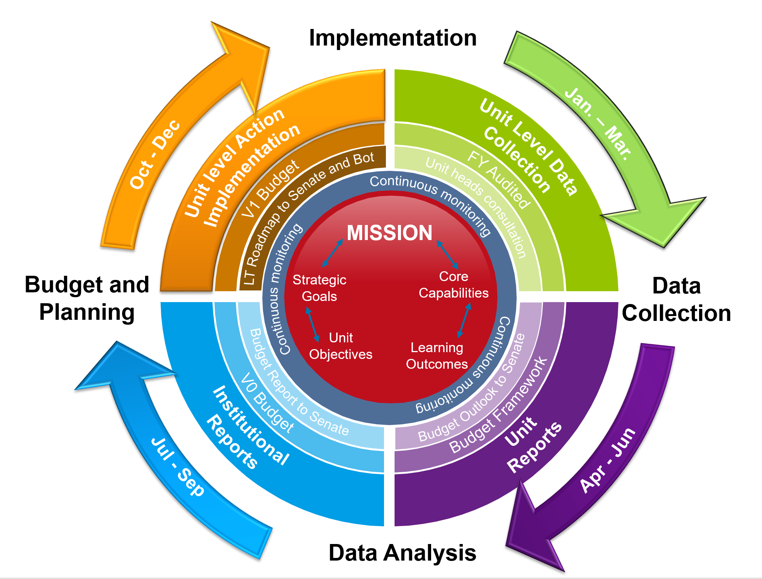

Mandatory Criteria

A Publicly Available Gender Equality Plan
This document, together with all referenced material, data gathering processes, links with the current strategic plan, dedicated personnel, mandated employee training, and relevant policies, constitutes the University’s Gender Equality Plan. The GEP is endorsed by the Provost of the University (Dr. Hannah Westley) and the Dean for Institutional Effectiveness (Prof. Claudio Piani).

Resource Commitment and Expertise in Gender Equality
The GEP leadership sits partly in the AUP Diversity Council comprised of two staff representatives (Camille Davis from the Admissions Office and Tahmineh Farhat from the AUP Bookstore), two Faculty members (Prof. Bakul Sathaye and Prof. Evelyn Odonkor), and two students (Aanya Tiwari and Ira Mcintosh). The Diversity Council supports a culture of ever-greater diversity, equity, and inclusion at AUP. It functions as an advisory council and recommending body to the President and Provost, as a liaison to departments across the University, and as an advocate for all members of the AUP community who feel they have experienced bias or discrimination on the basis of race, color, religion, sex, national origin, age, size, disability, veteran status, sexual orientation, gender identity, or gender expression.
Essential to the data gathering and climate monitoring efforts of the GEP are the Dean of Student Development (Kevin Fore) and the Director of Human Resources (Stephanie Buisson). The Dean of Student Development oversees the deployment of student climate surveys monitoring events of sexual harassment, sexual misconduct and sexual assault on campus and on AUP students off campus. He oversees the implementation of student workshops (e.g.: on consent) and supports relevant student clubs (e.g.: AUP for Consent). The Dean also oversees student counselors, an essential resource for victims of misconduct on campus. The Director of Human Resources collects gender disaggregated data on faculty and staff focusing on pay, pay raises outside promotion, promotions, post maternity leave pay increase, and gender distribution of highest earners. She identifies gender relevant training needs for faculty and staff and provides mandatory training modules while monitoring participation.

Data Collection and Monitoring
As explained above, AUP gathers all relevant data on a cyclical basis. Disaggregated faculty and employee data is compiled by the Office of Human Resources and available on an annual basis. The data is structured in response to components one-through-five of the French Gender Equity Score which are closely aligned with three of the “recommended areas of focus” (see below). The data is too complex and granular to present here but it presented to the Board of Trustees of the University in the annual October meeting. As an example, figure2 below shows preliminary career progression data for 2023. Top and bottom panels refer to different faculty employment categories differentiated by their research obligations.
Figure 2
Career progression for Enseignant and Enseignant-Chercheur (preliminary data for 2022)

The top panel in figure 2 shows that, compare to men, a smaller proportion of women progress to the rank of full professor while the bottom panel shown no significant asymmetry between genders. These results are similar to what emerged from the data last year.
The University also tracks gender composition of the student body as a function of college level (academic career progression), major (field of study), and term (time). Since AUP has close to 26 majors and roughly 1400 students, granular disaggregated data may lose statistical significance but long term trends may still be helpful. Below (figure 3) is the gender makeup of the student body over the last few years and the average cumulative GPA for graduating undergraduates.
Quite apart from statistics of gender makeup, the Dean of Student Development collects data on cases of student sexual misconduct and related student grievances. These are presented in the annual assessment reports (figure 1, purple quadrant) along with suggested actions in response to emerging needs.
Figure 3
Student declared gender percentages since 2012.

Training on Gender, Equality and Unconscious Bias for all Staff and Decision Makers
All faculty and staff of the American University of Paris have recently benefited from a series of mandatory training modules in response to results from a general faculty and staff climate survey.
- A "Psychological Risk Prevention” webinar sponsored by the Office of Human Resources, distributed in Fall 2021, and focusing, among other things, on work-life balance and moral harassment.
- A “Diversity and Inclusion” webinar sponsored by the President’s Office and the Diversity Council, distributed in Spring 2022, and focusing, among other things, on sexual harassment and unconscious bias in the workplace.
Further pan-employee training sessions will be offered in the future in response to needs emerging from planned climate surveys.
Though not specifically mandated by the EU, AUP also support student facing training opportunities. Student sponsored cubs, such as “AUP for consent”, provide support and advice in the case of sexual misconduct and first response. In the future, this will include information resources about DFSA (drug facilitated sexual assault).

Recommended Areas of Focus

Work-Life Balance and Organizational Culture
Among the items associated with the French Gender Equity Score, is insuring that women who have been on maternity leave receive pay increases where increases have been awarded in their absence making maternity leave less threatening to career progression. Also, in support of a better balance between work and home obligations and in the wake of the global pandemic, AUP drafted a Remote work charter that allows for up to two days a week of remote work for all employees.

Gender Balance in Leadership and Decision Making
This area of focus is tangentially aligned with item #4, “parity in high-earners”, from the French Gender Equity Index. Apart from that, below are a list of all major decision-making bodies at the American University of Paris. Although there is no clear imbalance in gender composition among the whole of decision-making bodies, there is no specific policy mandating minimum quotas. The faulty senate could consider vetoing committees with a five-to-one or two-to-six composition.
Table 2
Gender Make up of Leadership and Faculty Governance
Group or Committee | Men | Women
Leadership Team (President and Vice Presidents | 4 | 4
Executive Committee of the Faculty Senate | 4 | 3
Rank and Promotion Committee | 4 | 3
Curriculum Committee | 2 | 7
General education Committee | 5 | 5
Ethics Committee | 2 | 2
Council of Chairs (Department Chairs) | 5 | 3
Graduate Program Review Board | 4 | 3
Council of Directors of Research Centers | 5 | 1
Academic Affairs Unit Directors (Provost’s Management Group) | 4 | 7
Deans, Associate Deans, and Assistant Deans | 2 | 2

Gender Equality in Recruitment and Career Progression
The American University of Paris has, and enforces, a non-discrimination policy (P.# BP023EN).
“The University promotes its educational goals and preserves the human rights of each of its members, notably by safeguarding freedom from discrimination on the grounds of sex, race, color, religion, national origin, age, disability, sexual orientation or gender identity. These values are affirmed by French law and Article 10, which ban expressions that incite discrimination, that propagate the idea of a superior race, and that spread hatred against specific groups.
AUP prohibits discriminatory behavior and seeks to foster a climate free from discrimination through coordinated education and prevention programs, clear policies, and a prompt and accessible grievance procedure. This policy provides the AUP community with clear standards, definitions, and descriptions of prohibited conduct. It also identifies resources and support for the AUP community and outlines the grievance process.”
In support of this policy, the University gathers and archives disaggregated data relative to items one-rough-three of the French Equity index, (“pay gap”, ”pay rise outside promotion”). Examples were given in figure 2.
AUP is particularly attentive to the condition and well-being of employees returning from maternity leave. A professional interview is set up with HR upon their return from maternity leave to review their return to work and support them if necessary. In addition, to secure a balance in salary progression between men and women all women returning from maternity or adoption leave receive a raise within a year of their return.

Integration of the Gender Dimension into Research and/or Teaching Content
The Department of Psychology Health and Gender houses the Gender Sexuality and Society major. Students in this major must “demonstrate knowledge of the developmental, social, theoretical and historical frameworks that define the study of gender and sexuality from both a social sciences perspective and a humanities perspective.” Apart from students in the major, courses coded as GS (Gender Studies) are available to all students and many are part of he General Education Program. (E.g.: “Contemporary Feminist Theory”, “Introduction To Gender, Sexuality, And Society”, and “Gender And Sexuality: Global Perspectives”). More importantly the department regularly sponsors public events (See Table 3, for recent examples)
Table 3
Selected Gender Themed Events
GENDER, INCLUSIVITY AND TECHNOLOGY WITH SPEAKER GABRIELA RAMOS (UNESCO)  THURSDAY | FEBRUARY 3, 2022
GENDER AND MEDIEVAL STUDIES CONFERENCE 2022: RESILIENCE, PERSISTENCE, AND AGENCY | JANUARY 7, 2022
A WORLD BEFORE RACE? GENDER, MOBILITY, AND PROPERTY IN THE EARLY MODERN IBERIAN WORLD | DEMOS21 | MARCH 15, 2021

Measures Against Gender-Based Violence Including Sexual Harassment
The American University of Paris has, and enforces, an explicit sexual and moral misconduct policy (P. # HR014EN).
“Sexual and moral misconduct are violations of a person’s rights, dignity and integrity, and such acts are contrary to the mission and values of The American University of Paris. AUP prohibits these violations and seeks to foster a climate free from misconduct through coordinated education and prevention programs, clear policies, and a prompt and accessible grievance procedure. This policy provides the AUP community with clear standards, definitions, and descriptions of prohibited conduct. It also identifies resources and support for the AUP community, and outlines the grievance process.”
In support of the policy itself, climate surveys of both employee and student populations are deployed on a regular basis. Also, records of instances of reporting of sexual and moral misconduct are compiled by Human Resources for employees and by Student Development for students.

Is a French umbrella term for most forms of harassment that involve an abuse of the employment relations.

